After nmap scan results only port 21, 80 are open after viewing the webserver IIS7 is using and I capture the requestrs on burp and confirm ASP header is using. So I have decided to drop ASPX reverse shell through ftp port as the anonymous login is present.

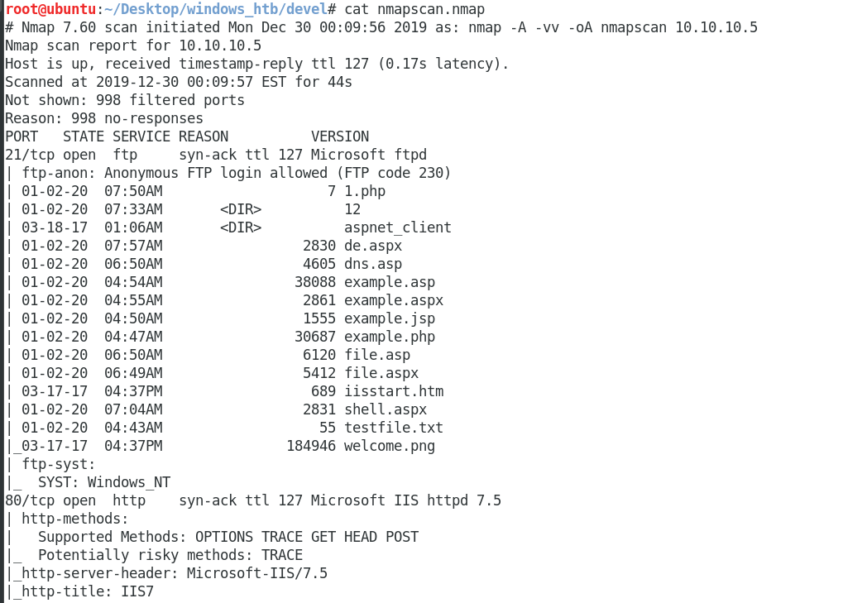

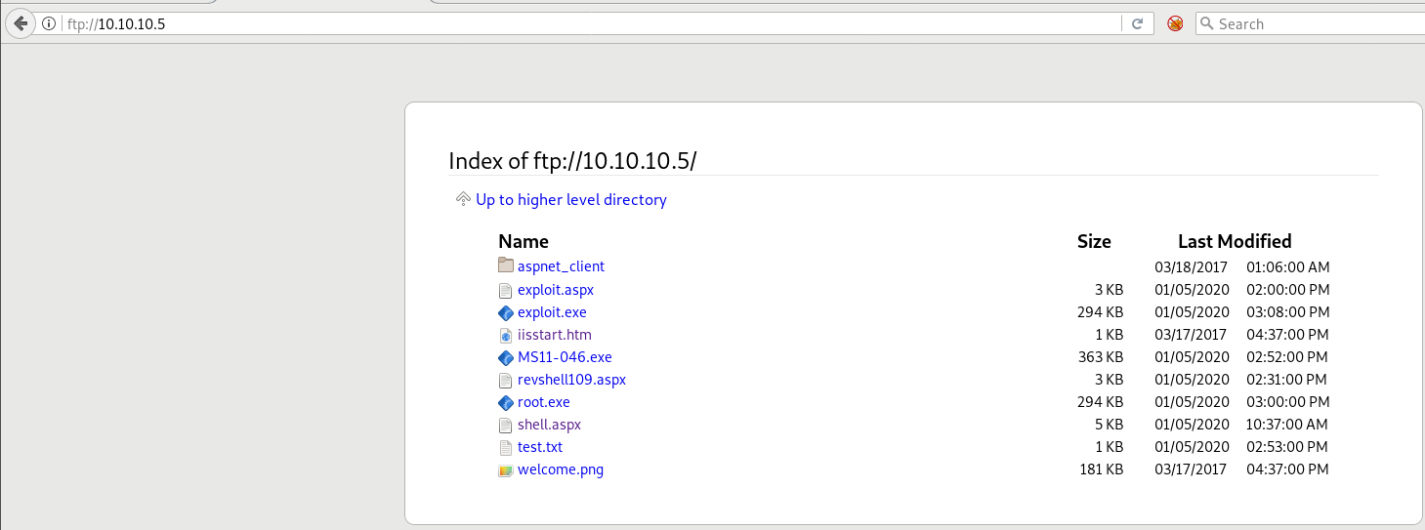

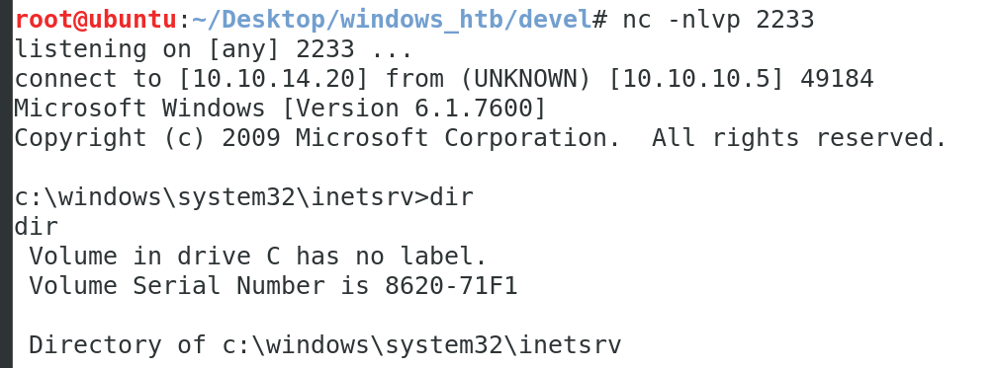

As we are low privilege user have to escalate the root privileges



